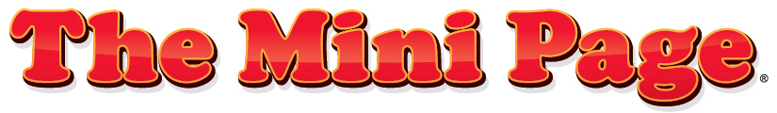

Educational Standards and Suggested Activities for Teachers

Issue 27
Release week: July 6-12, 2019

Standards Spotlight: Visit Mount Rushmore
Mini Page activities meet many state and national educational standards. Each week we identify standards that relate to The Mini Page’s content and offer activities that will help your students reach them.

This week’s standard:

• Students understand that the visual arts have both a history and specific relationships to various cultures. (Art)

Activities:

- Fold a piece of paper into four sections. Write the name of one of the Mount Rushmore presidents in each of the sections. In each president’s square, paste newspaper words and pictures that describe that president.
- In the newspaper, circle tools and equipment someone might use to make a life-size monument. The monument can be made of stone or wood.
- Find four important leaders today in the newspaper. Explain why you chose these people.
- How are these related to Mount Rushmore: (a) Theodore Roosevelt, (b) 450,000 tons of rock, (c) Lakota people and (d) Gutzon Borglum?
- Use the internet and community information publications, like tourist brochures, to learn more about your community. Design a monument that represents something important in your community. Draw a picture of your monument and write a paragraph explaining why it is important.

Standards by Dr. Sherrye D. Garrett, Use the News Foundation.

Learn more about The Mini Page and get in touch at universaluclick.com/text_features/minipage.

Like The Mini Page on



