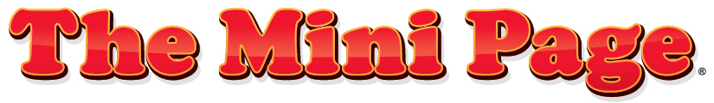

Educational Standards and Suggested Activities for Teachers

Issue 32
Release week: Aug. 10-16, 2019

Standards Spotlight: Be a Social Helper
Mini Page activities meet many state and national educational standards. Each week we identify standards that relate to The Mini Page’s content and offer activities that will help your students reach them.

This week’s standard:

• Students demonstrate respectful and caring relationships in the family, workplace and community. (Family and Consumer Science: Interpersonal Relationships)

Activities:

- Look in the comics section for comic strips that show someone being a social helper. Paste the strips on a piece of paper. Under the strip, write a sentence explaining how the character is being helpful.
- In the newspaper, circle any pictures or stories that show people who are demonstrating the positive traits of a social helper that are listed in today’s Mini Page.
- Look for news stories that show someone in a situation where someone might need a social helper. Paste the story on a piece of paper. Under the story, explain what you would do to help the person.
- How are these situations important for social helpers: (a) in the lunchroom, (b) on the playground, (c) in the classroom and (d) on the bus?
- Get together with friends and talk about situations in your school where you’ve seen people who were in situations where a social helper was needed. Make a list of at least five things that you and your friends promise to do to help other students in your school.

Standards by Dr. Sherrye D. Garrett, Use the News Foundation.

Learn more about The Mini Page and get in touch at universaluclick.com/text_features/minipage.

Like The Mini Page on



